



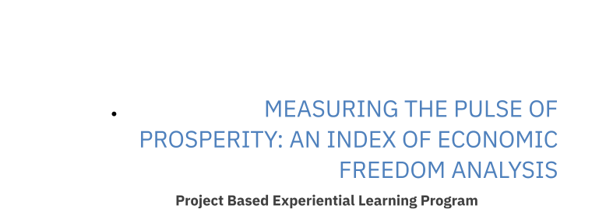

Measuring the Pulse of Prosperity: An Index of Economic

Freedom Analysis

Milestone 1: Define Problem / Problem Understanding

**Activity 1: Specify the business problem**

Refer Project Description

### Activity 2: Business requirements

The business requirements for this project would likely include the creation of an index or metric that measures the level of economic freedom in a given country or region. This index would likely be based on a variety of factors such as the size and role of government, the level of regulation, the freedom of trade and investment, and the property rights and rule of law. The index would then be used to compare the economic freedom of different countries and regions, and to identify trends and patterns over time. The final outcome of this project would be a report or publication that presents the findings of the analysis and provides recommendations for policy and economic development.

### Activity 3: Literature Survey (Student Will Write)

. A large literature has found positive associations between economic freedom and income, growth, and a variety of other desirable outcomes. This paper surveys the literature that seeks to explain the causes of economic freedom. Some of the most consistent findings in this literature are that current levels of economic freedom are strongly correlated with past levels; freer countries have more difficulty continuing to improve their economic freedom; democracy and political freedom are positively associated with economic freedom; and inequality is negatively related.

**Activity 4: Social or Business Impact.**

**Social Impact:** A high level of economic freedom is usually associated with higher standards of living, more opportunities for individuals to improve their economic status, and greater access to goods and services.

**Business Model/Impact**: a high level of economic freedom would likely indicate a more favourable business environmen